**Who command:-**

Displays the username and time of all currently logged in users.

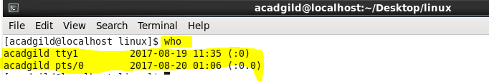

There are many options available under who command. I have explained few basic options that is available under who command.

**-b option in who command:-**

-b option in who command gives the time of last system boot. You can refer it in below screenshot

